Adder application:

Maintains Customer > Commitment > commitment plan

Track commitment plan.

Penalize as required.

2 billing systems – BAL, ANTILLIA

1 billing system for Mobile – DISE3g

1. Customer is registered
2. Commitment plan (contracts) will be created against Customer.

Contract > Legal Entity > different accounts

Adder gets billing acc details from CMF

Penalizing Events: 1 year, rollover, cease, regrade

3 ways to create plans – Agent desktop, shop, Adder GUI

Agent desktop, shop plans comes through BAL into Adder.

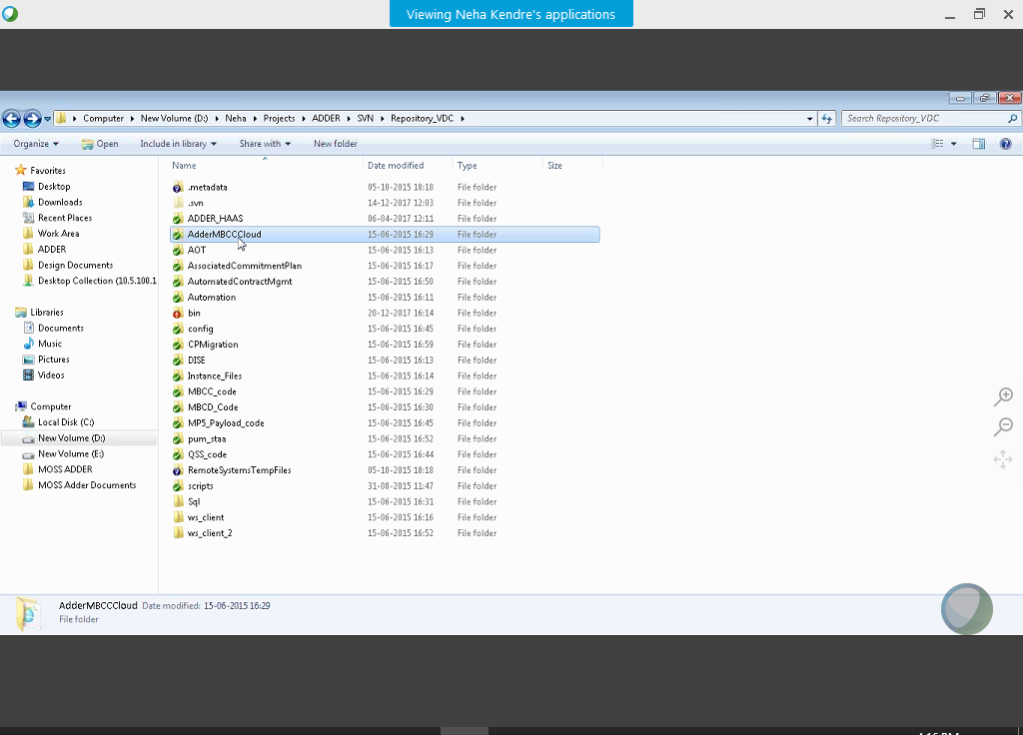

BT Security links:

* [BT Security access control and management specifications](https://intra.bt.com/bt/security/policy/non-technical%20security%20specifications/ACM/Pages/index.aspx)
* [Information Classification and Security Standard](https://intra.bt.com/bt/security/policy/everyone/secpol4/Pages/classification.aspx)
* [Legal & Compliance team](https://intra.bt.com/bt/lgc/Pages/index.aspx)
* [Cryptography Specifications](https://intra.bt.com/bt/security/policy/non-technical%20security%20specifications/cryptography/Pages/index.aspx)
* [Advice on how to avoid phishing scams](https://intra.bt.com/bt/security/me/howdoi/at_work/Pages/avoid-phishing-scams.aspx)
* [Information on BT approved mobile security software](https://fixit.bt.com/Lists/How%20To%20Articles/DispForm_Cust.aspx?ID=1939)
* [Internet, E-mail and Messaging Acceptable Use Policy](https://intra.bt.com/bt/security/policy/everyone/secpol3/Pages/index.aspx)

